**Predicting Hospital Readmission for Patient with Diabetes**

**PROJECT REPORT**

**Submitted by**

**Kaggle Geeks**

**Team**

Harish Kumar Reddy G

ReddyRani P

Mohamad Ali S

Manjula L

Niveda C

***In partial fulfilment for the award of the Certificate***

**OF**

**SUMMER INTERNSHIP PROGRAM**

 

**Department of Computer Science and Engineering**

**Annamacharya Institute of Technology and Sciences**

**Venkatapuram Village, Renigunta Mandal, Tirupati, Andhra Pradesh 517520**

**July 2019.**

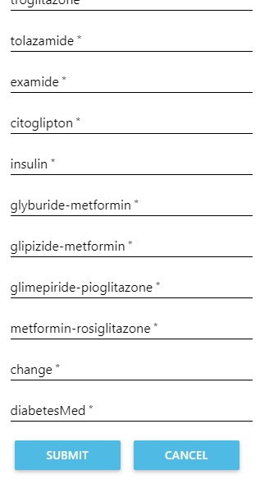

### BONAFIDE CERTIFICATE

This is to certify that the project entitled ”**PROJECT TITLE**” submitted by **Team Members Names** in partial fulfilment for the requirements for the award of internship certification in technologies of Machine learning and Deep learning is an authentic work carried out by them under my supervision and guidance.

To the best of my knowledge, the matter embodied in the project report has not been submitted to any other University/Institute for the award of any Degree or Diploma.

### Signature of Supervisor                                       Signature of HOD

Akshay Kumar Kothuri, M.Tech       Mrs.B.Rupa Devi M.Tech, Ph.D.,

AI & IoT Developer Assistant Professor & HOD,

SmartBridge Educational Services PVT LTD Department of CSE,

Hyderabad – 500096 AITS, Tirupati.

**Predicting Hospital Readmission for Patient with Diabetes**

**Abstract:**

Hospital readmissions increase the healthcare costs and negatively influence hospitals’ reputation. Predicting readmissions in early stages allows prompting great attention to patients with high risk of readmission, which leverages the healthcare system and saves healthcare expenditures. Machine learning helps in providing more accurate predictions than current practices. In this work, an approach that balances between data engineering and neural networks’ ability to learning representations is proposed for predicting hospital readmission among diabetic patients. A combination of Convolutional neural networks and data engineering were found to outperform other machine learning algorithms when employed and evaluated against real life data.

**PYTHON:**

Python, as a high level programming language, allows you to focus on core functionality of the application by taking care of common programming tasks. The simple syntax rules of the programming language further makes it easier for you to keep the code base readable and application maintainable. Main reasons to use python language is:

1. Readable and Maintainable Code

2. Multiple Programming Paradigms

3. Compatible with Major Platforms and Systems

4.  Robust Standard Library

5. Many Open Source Frameworks and Tools

6. Simplify Complex Software Development

7. Adopt Test Driven Development.

**Machine learning:**

Machine learning is an subset of artificial intelligence (AI) that provides systems the ability to automatically learn and improve from experience without being explicitly programmed. Machine learning focuses on the development of computer programs that can access data and use it learn for themselves. The process of learning begins with observations or data, such as examples, direct experience, or instruction, in order to look for patterns in data and make better decisions in the future based on the examples that we provide. The primary aim is to allow the computers learn automatically without human intervention or assistance and adjust actions accordingly.

Basically Machine Learning is of three types:

1.Supervised Learning: Learning from characterized data.

2.Unsupervised Learning: Learning from raw data.

3.Reinforcement Learning: Learning from self mistakes (or) self learning data.

Predictive modelling is the way of building a model that is capable of making predictions. The process includes a machine learning algorithm that learns certain properties from a training dataset in order to make those predictions. Predictive modelling can be divided further into two areas: Regression and pattern classification. Regression models are based on the analysis of relationships between variables and trends in order to make predictions about continuous variables. In contrast to regression models, the task of pattern classification is to assign discrete class labels to particular data value as output of a prediction Here we used multiple linear regression algorithm to predict the future power consumption rate.

**Steps involved in Machine learning:-**

Steps involved in the machine learning is shown in the below figure

1. Data Collection

2. Data Wrangling

3. Analyse the data

4. Train the algorithm

5. Test Algorithm

6. Deployment

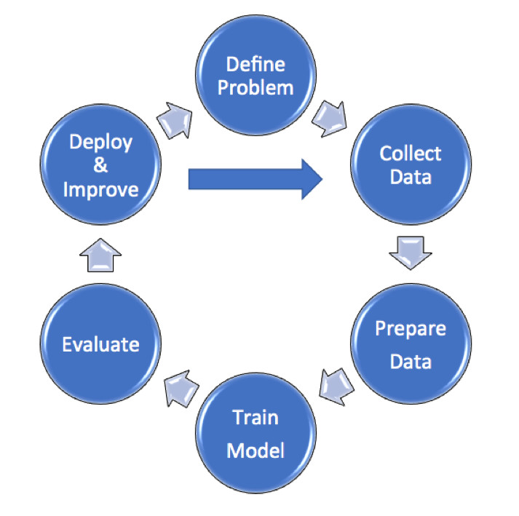

**Data collection:**

Here we collect the data from the power departments and we use previous data and predict the future power consumption

**Data Pre-processing:**

In this phase, the data is prepared for the analysis purpose which contains relevant information. Pre-processing and cleaning of data are one of the most important tasks that must be one before dataset can be used for machine learning. The real-world data is noisy, incomplete and inconsistent. So, it is required to be cleaned.

**Extraction of Feature Set/Training Data**

The feature sets and training set that has obtained by using any of the methods will be used for the implementation of machine learning algorithms.

**Implementation of Machine Learning Algorithm on Feature Set/Training Data:**

**Regression:**

A Regression model is created when we want to find out a number – for example: How many days before a patient discharged from hospital with a chronic condition such as diabetes will return.

**Classification:**

To determine a label or category – it is either one thing or another. We train the model using a set of labelled data.

**Testing of Data:**

Testing of data is done based on training model which is classified using supervised learning algorithm. Evaluation of the total responses for every question and determine the polarity of feedback received in context of the given data.

**Multiple Linear Regression:**

Multiple Linear Regression is the most common form of linear regression analysis.  As a predictive analysis, the multiple linear regression is used to explain the relationship between one continuous dependent variable and two or more independent variables.  The independent variables can be continuous or categorical (dummy coded as appropriate). The multiple linear regression algorithms is having one and more independent variables and one dependent variable. Here it consist of hyper plane i.e. is all the straight lines joined together is called hyper plane. The iterations are performed up to a0=0. The equation of the multiple linear regression y=a0+a1*x1+a2*x2........

**1.2. Objective of research**

The above problem made me to go for a research about how can we predict the power consumption for making easier. Through many documentation and cases, it came out that machine learning and data science can make the work easier and faster. The objective of this project is to analyze dataset which consist of power criteria per span of time and predicting the power consumption which may happen in future depending upon dataset consisting of previous data.

**1.3. Problem Statement**

Predict if a patient with diabetes will be readmitted to the hospital within a certain period of time.

**2. Review of literature**

[**https://github.com/andrewwlong/diabetes_readmission/blob/master/diabetic_data.csv**](https://github.com/andrewwlong/diabetes_readmission/blob/master/diabetic_data.csv)

The dataset used in this project is taken from Github.

**3. Data Collection:**

The data is collected and uploaded in the Jupiter notebook in Anaconda navigator. we use pandas , numpy and we declare pandas as pd and numpy as np. And we assign dataset to dataset variable by using "pj.csv" following with dataset name and we print the dataset. And next we slice the data with independent variables as x and dependent variable as y. here the independent variables.we convert the data set into arrays using ".values".

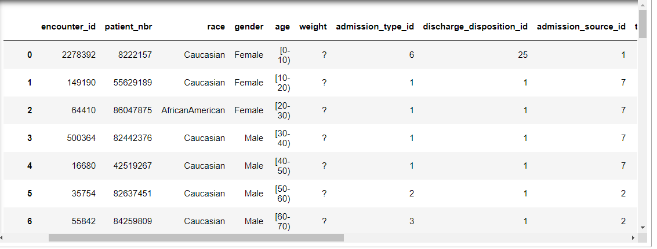

**4.1 Statistical techniques:**

Logistic regression is a traditional machine learning model that fits a linear decision boundary between the positive and negative samples. This linear function is then passed through a sigmoid function to calculate the probability of the positive class. Logistic regression is an excellent model to use when the features are linearly separable. One advantage of logistic regression is the model is interpretable — i.e. we know which features are important for predicting positive or negative. One thing to consider is that the modeling is sensitive to the scaling of the features, so that is why we scaled the features above. We can fit logistic regression using the following code from scikit-learn.

From "sklearn.model_selection" we import "train_test_split " ,and we declare variables x_train, x_test, y_train,y_test and these are assigned to train_test_split of x,y with test_size =0.2, and we declare here random_state as zero.

Random Sampling (Train and Test)

Training Sample: Model will be developed on this sample. 70% or 80% of the data goes here.   Test Sample: Model performances will be validated on this sample. 30% or 20% of the data goes here.

**4.2 Data modelling:**

From sklearn.linear_model we import the linear regression and we assign "lr" variable with linear regression and then we give the splitted values to the model with "fit" .to predict the values we use predict. Here our input independentattributes are:

encounter_id,patient_nbr,race,gender,age,admission_type_id and so on........

4.3 **PROJECT LINK:**

[**https://eu-gb.dataplatform.cloud.ibm.com/analytics/notebooks/v2/5b10eb9f-8d1c-484e-a4fc-5932391a69f9/view?projectid=8ee64fb5-fb35-49a1-b8f4-6f32c68cb231&context=analytics**](https://eu-gb.dataplatform.cloud.ibm.com/analytics/notebooks/v2/5b10eb9f-8d1c-484e-a4fc-5932391a69f9/view?projectid=8ee64fb5-fb35-49a1-b8f4-6f32c68cb231&context=analytics)

**4.4 Prediction form:**

[**https://tinyurl.com/yyd28pcs**](https://tinyurl.com/yyd28pcs)

|  |  |  |  |  |  |  |  |  |  |  |  |  |
| --- | --- | --- | --- | --- | --- | --- | --- | --- | --- | --- | --- | --- |
|  |  |  |  |  |  |  |  |  |  |  |  |  |

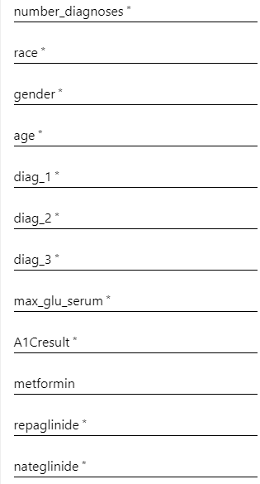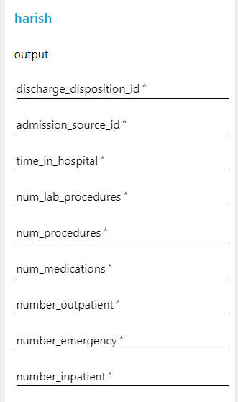



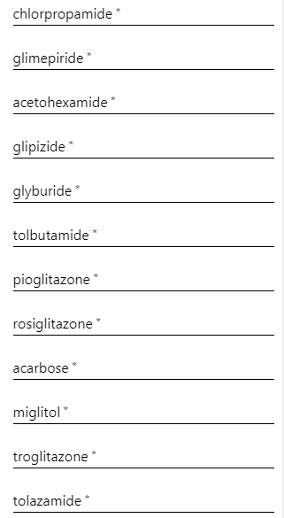

**4.5. conclusion :**

**Pros :**

* It is helpful for the hospital management people to provide better services to the patients
* Improves hospital services
* Get to know about investment where to keep
* Optimize the cost of expenditure
* Know to feature investment of health insurance compan**y**

**Cons :**

* Will not predict 100% accuractly but predit 80% accuractly
* Predicting outcomes rarely not expected outcomes

**Feature inventions :**

* To increase the income of a company like a health insurance we need to provideoutcome as 3 ouputs and also need to groupby() the categories those who are joining in with in 30 days , more than 30 days , those who will not join and display the count for the providing hospital reimbrussments .
* We have not implemented date wise patient visit to the hospital
* We will provide this feature as next update .

**Good thing in project :**

* Reducing hospital management risk to maintain the patients in waiting hall.
* Suggesting them to provide services to the patients when patients are more that day